Administrative clean-up edits
- Added missing “«” or “»” to «Customer Name»
- Added missing “’s” to «Customer Name»
- Added missing periods; deleted extraneous periods and commas
- Deleted extra spaces
- Corrected font size, spacing and indentation
- Added and/or corrected pink text indicating the end of an option
- Corrected the page numbering in exhibit footers
- Corrected section numbers and section references
- Decapitalized the word “of” in a header

Specific word changes made as clean-up edits:
- BPA added or revised pink text drafter’s notes for clarity:

  - Instance 1, in Exhibit B, section 1.2.2:
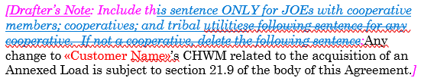

  - Instance 2, in Exhibit I, section 1.2, in the space for an additional Customer Name contact box:
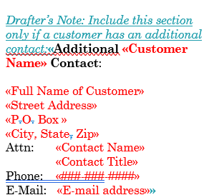

- BPA identified and corrected a mistake in the Load Following template, Exhibit C, Option 2, sections 2.3 and 2.4 (JOE option language). Edits that were intended for Exhibit C, Option 2 (for JOEs), section 2.4 were accidently put into Exhibit C, Option 2 (for JOEs), section 2.3. The following redlines show how BPA corrected the mistake. The corrected language is now aligned with the non-JOE options 1 of these sections. The correction is also addressed in Issue 53 of the Provider of Choice Contract Record of Decision.

Exhibit C, 3rd paragraph of section 2.3.1
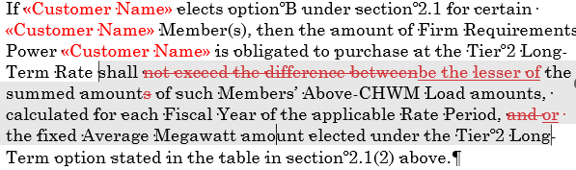

Exhibit C, 3rd paragraph of section 2.4
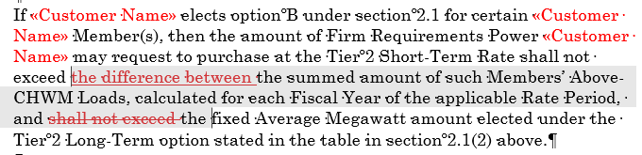

- In the CF/CT table in Option 2 of section 1.1 of Exhibit D (for those customers with a CF/CT), BPA changed “MW” to “aMW”.
- In Slice/Block template, Exhibit F Section 4 (for customers served exclusively or partially by transfer service), BPA made the following edit:

“4. CUSTOMER INPUT AND BOS FLEX SUBMISSION DEADLINE
«Customer Name» shall have until 0800 hours Pacific Prevailing Time (PPT) on of each Slice Scheduling Day to submit revised Customer Inputs and BOS Flex requests for each Slice Operating Day, pursuant to section 7 of Exhibit L.”
- Deleted “the” from “the «Customer Name»” in Option 2 of Exhibit G (for customers served by Transfer Service, all products), section 3.2.1.
- Deleted “Power” from “Power Account Executive” from the BPA contact box in Exhibit I section 1 for all products.

