Slice used to Serve Total Retail Load
Historical Inputs and Proposed POC Performance Standard
Annual RSO Test
BPA evaluated historical RSO inputs for seven selected customers for four fiscal years including 2018, 2022, 2023, and 2024.
Customer names are masked using A-F. Two years of annual RSO test results are included in each of the annual RSO test charts provided below. The percentage provided in the charts below represents the Slice used to serve Total Retail Load compared to 95% of the Customers’ annual RSO minimum. The annual RSO minimum was calculated using the sum of each monthly RSO minimum.
Jan-Jul Water supply at The Dalles Dam was 80.3 MAF in FY2023 and 78.8 MAF in FY2024. The water supply in the two most recently completed fiscal years was lower than the average of 103.7 MAF. Customers passed the RSO annual test in all instances. One customer had a year at 96.5 percent that was close to failing the annual RSO test.
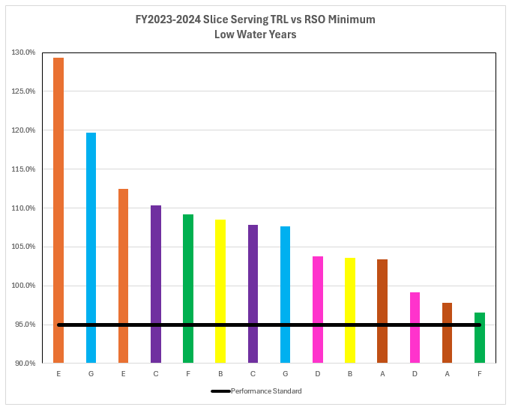

Jan-Jul Water supply at The Dalles Dam was 118.7 MAF in FY2018 and 105.8 MAF in FY2024. The water supply in the two selected years is significantly higher than the average of 103.7 MAF. Customers exceeded the 95% annual RSO test performance standard significantly in all instances in the two selected high water years.
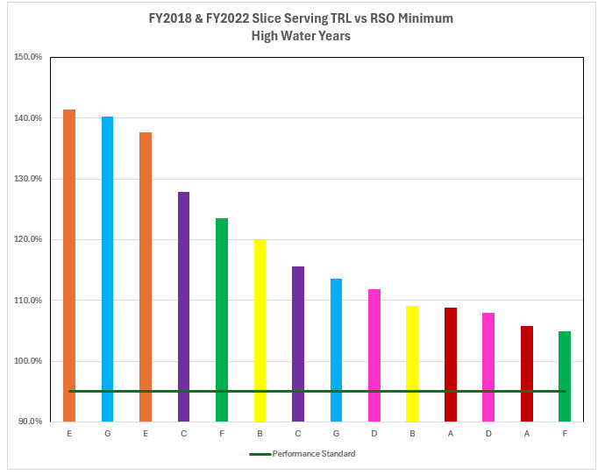
Monthly RSO Test
BPA evaluated historical monthly RSO test inputs against a performance standard of Slice used to serve Total Retail Load is greater than 85% of RSO minimum. The sample size includes 357 months of RSO inputs for seven customers in FY2018, 2022, 2023, 2024, and 2025 thru December 2024. There were zero instances of a customer failing the monthly performance standard of 85%. There were a limited number of instances where customers were close to failing the 85% performance standard, the performance ranges and number of instances are provided below.

Monthly RSO Test Performance Range | # of Months in the Performance Range
85.0% - 86% | 1
86.1% - 87% | 1
87.1% - 88% | 3
88.1% - 89% | 1
89.1% - 90% | 5

