**MSM – Metering Services**

**Data Edit Method / VEE Logic**

**Date Last Updated:** 9/26/2024

**Procedure Owner:** Atzel Santiago Cruz

**Unique ID:** [ID]

Table of Contents

1. Introduction 3

1.1 Purpose 3

1.2 Point of Contact 3

1.3 Prerequisites 3

1.4 Applicability 4

1.5 Terms, Definitions and Acronyms 4

1.6 Authorizing Policies 4

1.7 Roles and Responsibilities 4

2. Procedure 4

2.1 Outputs and Impacts 4

2.2 Procedure Steps 5

2.2.1 Select an estimation methodology 5

2.3 Information Governance 6

3. Process Map 7

4. References 8

4.1 Standards 8

4.2 Guidelines 8

4.3 Forms, Templates and Checklists 8

4.4 Training 8

5. Review 8

5.1 Procedure Evaluation 8

5.2 Review Timeline 8

# Introduction

## Purpose

The VEE (validating, editing, and/or estimating) process is required to ensure data availability and accuracy for all incoming meter reads from any source, to make these interim and final values available for a variety of downstream puroses included Billing, Load Forecasting, Scheduling, EIM Settlements, and External Customer Review. Specifically for EIM-Settlements and CAISO submission purposes, CAISO requires documentation regarding how each Participant will process meter interval amounts to ensure practices are in accordance with CAISO standard requirements.

Meter points require an edit when some or all of the served load or generation has not been recorded by the meter. This can be due to a number of situations, with the most common being maintenance, an irregular system configuration, inaccurate energy recording, a loss of phase (LOP), or a meter device malfunction. In these situations, an edit is authorized by the BPA field personnel (or possibly by the customer) and a Meter Data Analyst (MDA) will edit meter point data for an agreed upon time range with the objective being to accurately reflect load/generation. Collaboration with the customer and their endorsement of the final an edit product is preferred for complex or longer term edits.

This document outlines the circumstances and considerations for selecting one edit method over another. The goal of the edit is to come up with reads that fit in seamlessly with the surrounding reads. When done with precision, a person reviewing the edited reads should not be able to “pick them out” from the valid surrounding reads without other markers being used.

Periods for which unmetered edits are required may run from as little as a few minutes, too many months, though the vast majority will be only around one hour, affecting one or two hourly reads. All edits require an event in PowerOptix-MDM by the assigned MDA, indicating why the edited was needed, what method was used, and if the edit is complete or not. As needed, an edit will require event documentation and checkout processes showing the resolution process of the edit.

## Point of Contact

MSM – Metering Services is responsible for determining the correct validating, editing and estimation methodology to apply to the data, and ensuring the completion of the estimation.

## Prerequisites

* Access to PowerOptix as a Meter Data Analyst (MDA)

## Applicability

* Manual and/or automated validations apply to all meter interval amounts processed by MSM meter systems.
* Edits or estimates are performed by the assigned MDA if authorized by BPA Personnel, specifically System Protection Control (SPC) or Customer Service Engineering CSE) via an email or the receipt of a Meter Maintenance & Outage MM&O (MM&O) form.
  + Does not include edits made by TEZP to check out WIT values which will be used to shape interchange amounts to for EIM-Settlements purposes.
* Edits or estimates are performed by the assigned MDA if authorized/requested by the Customer via an email.

## Terms, Definitions and Acronyms

*Automated Validation:* The standard and complex rules each group of meter interval reads coming into MSM’s systems are automatically run against, in accordance with the load shape, type, source, and alternate sources such as SCADA or B-meters. Automated validations alert on immediate issues, especially regarding standard communication or load issues, but are used as an inform only. Additional visual validation is always required to research issues further. (This function is in development and will be available in PowerOptix sometime in FY25).

*Interval Data Edit:* After-the-fact data that has been calculated based on standard edit rules because raw data was not available or valid. When this occurs, a calculation of what the load should have been is performed based on algorithms developed and approved by Metering Services.

*Interval Data Estimation*: Projected data that has been calculated based on standard estimation rules because raw data was not available. When this occurs, a calculation of what the load should have been is performed based on algorithms developed and approved by Metering Services until the actual load is retrieved from the device and overrides the projected estimate. This is rarely done in MSM and instead, is handled by PTKT using their ISAAC software for transfer scheduling purposes, as well as MSL using their ALF software for short-term load forecasts. These situations only occur currently when EIM generation meters on the trouble log beyond 3 days and the MSM EIM SME decides to substitute missing data with backup reads until the site communications are resolved, at which time the valid reads will automatically override the estimated reads.

*Visual Validation:* The processes required by MSM MDAs to visually review all revenue quality meter amounts for anomalies or other inaccuracies that the automated validations may not alert on. Visual validation is required to identify potential anomalies and used to work with the field and customer contacts to resolve issues. Due to the complexity and financial impacts of BPA revenue metered loads, even a small error can cause a large financial impact to BPA’s customers. Therefore, BPA cannot rely on automated validations alone to confirm metered amounts are correct.

MSM common terms, definitions and acronyms are located [here](https://bpa-bg.bud.bpa.gov/Default?ReturnUrl=/).

More detailed definitions of items above plus additional terms can be found by accessing the [Metering Services Terms to Know](https://portal.bud.bpa.gov/orgs/cust-sppt-svcs/KSM%20Metering%20Services/Process%20and%20Workflow%20FUTURE%20STATE/Shared%20Documents/Metering%20Services%20Terms%20To%20Know.docx) document.

## Authorizing Policies

MSM internal procedure

## Roles and Responsibilities

* MSM – Metering Services is responsible for determining validation, edit and estimation methodology, completing estimations, and documenting the estimation in an event.
* Customers, BPA service personnel, MS personnel, and the rest of BPA have the ability to view these estimations in MDMR2 and inquire about the methodology used.

# Procedure

## Outputs and Impacts

The goal of VEE is to ensure data is accurate for downstream users, including Customer Billing, Load Forecasting, Transfer Scheduling, EIM-Settlements, and external customers. At the time final data is needed for each systems, the data from MSM should have been run through both automated and multiple visual validations, all missing or erroneous load accounted for via edits/estimations, and then all meter events should be created to alert downstream users of the status of the issue and its final or expected resolution.

## Procedure Steps

### Automated validations

#### Add automated validation sets to new meter points. All new data feeds into MSM require the assignment of automated validation sets depending on the load type, shape, relationship with other meters, and potential backup sources. Click here for a high level guide for adding validation sets. *This language will be updated once automated validations are working in PowerOptix – aiming for some time in FY25. Language is copied over from pre-Hartigen processes.*

#### Monitor automated validation warnings/failures. Each time a set of reads comes into MSM systems (pull from the meter or manually entered) the data is run against the set of ‘rules’ for which is should pass. When interval reads or communication issues fall outside of set tolerances for that particular meter and rule, a warning or failure will appear in a validation queue for processing and further visual research. Validation queue processing depends on the time availability of each MDA but is generally weekly. A warning or failure will not inhibit data from flowing downstream. *This language will be updated once automated validations are working in PowerOptix – aiming for some time in FY25. Language is copied over from pre-Hartigen processes.*

### Visual validations

Visual validation of meter data is essential for detecting metering issues that may result in inaccurate customer usage amounts and/or a delay in the customer release due to waiting on a research verification.

#### Mid-Month and [End of Month](https://portal.bud.bpa.gov/orgs/cust-sppt-svcs/KSM%20Metering%20Services/Process%20and%20Workflow%20FUTURE%20STATE/Shared%20Documents/End%20of%20Month%20Meter%20Point_Customer%20Validation.docx) Validations: Each Meter Data Analyst will validate (verifying any anomalous data to determine if it is a legitimate event, or needs estimation) all assigned customers around the 15th day of the month, prior to the end of the month and prior to releasing customer data for billing. This procedure will outline the steps of how to pull and display data for validations only. Reviewing the data is covered in the procedure [Visual Validation of Meter Data](https://portal.bud.bpa.gov/orgs/cust-sppt-svcs/KSM%20Metering%20Services/Process%20and%20Workflow%20FUTURE%20STATE/Shared%20Documents/Visual%20Validation%20of%20Meter%20Data.docx). Taking action on an anomaly is covered in the procedure [Sending a Research Request Email](https://portal.bud.bpa.gov/orgs/cust-sppt-svcs/KSM%20Metering%20Services/Process%20and%20Workflow%20FUTURE%20STATE/Shared%20Documents/Sending%20a%20Research%20Request%20Email.docx).

#### [Multi-Month Validations](https://portal.bud.bpa.gov/orgs/cust-sppt-svcs/KSM%20Metering%20Services/Process%20and%20Workflow%20FUTURE%20STATE/Shared%20Documents/Multi-Month%20Customer%20Validation.docx): Each Meter Data Analyst (MDA) will validate all assigned customers for a 3-month period (or longer if necessary) to determine potential load issues, such as loss of phase, which may be overlooked or not noticeable in a monthly validation.

### Edit and estimation methodology options

All edits and estimations in MSM fall under the methodologies listed below. Edits are the most common, with methodologies applied to correct data after-the-fact. Only in rare occurrences would MSM estimation future data, or fill in data for Customer Billing while expecting it to be overwritten eventually. *Note: MSM does not use any embedded meter data software to assist in current editing or estimation tasks.*

1. **Linear Estimation (or Simple Average Projection)**
   1. If the amount of data to be estimated is two hours or less, the MDA may use Linear Interpolation – this allows you to estimate using the selected hours immediately before and after to create a straight line average. An example of this can be found [here](https://portal.bud.bpa.gov/orgs/cust-sppt-svcs/KSM%20Metering%20Services/Process%20and%20Workflow%20FUTURE%20STATE/Shared%20Documents/Linear%20and%20Shape%20Estimation%20Example%204-2014.xls)
   2. The Meter Data Analyst can also make the determination to use a different method if a straight line simply will not fit with the shape of the load (i.e.; wind, etc.…)
2. **Average Daily Load Estimation (aka Like Day/Prior Month/Prior Year Average) and Load Profile (shape) Estimation (Complex Edits):**
   1. If the amount of data to be estimated is greater than two hours the Meter Data Analyst uses their discretion to select the best method for the load shape. Different types are as follows:
      1. **Customer Supplied Data**
         1. In some cases the customer may have their own set of complete data that they can provide to us to fill in.
   * This is optimal since the reads entered are actual
     1. **SCADA match**
        1. A subset of our meters has a good SCADA match identified for them which the MDA can also use to estimate the data. To see if there’s a match, users can pull the hours down net report and under ‘Additional Resources’ add ‘SCADA’. If data comes back, there’s a match.
        2. Another way to check is to pull that location number on Meter Point. If there’s a current meter point row that has a type of ‘SCADA’, then there’s a match and data can be pulled by following directions under number 1 above.
   * Very similar to the Load profile matching estimation routine.
     1. **Like-Day Average**
3. This method uses like days and hours within the same month to estimate the selected hours;
   * Like days could mean the same day of the week (i.e.; Thursdays), or it could mean weekdays vs weekends or holidays. An example of this can be found [here](https://portal.bud.bpa.gov/orgs/cust-sppt-svcs/KSM%20Metering%20Services/Process%20and%20Workflow%20FUTURE%20STATE/Shared%20Documents/Average%20Daily%20Load%20Estimation%20Example.docx)
4. The MDA determines how many like days, and which ones, they want to use in the average.
   * 1. **Like Prior Month Average**
        1. This method uses like days and hours within the prior month to estimate the selected hours
     2. **Like Prior Year Average**
        1. This method uses like days and hours within the same month prior year to estimate the selected hours
     3. **Load Profile (shape) Matching**
        1. This method allows the MDA to base the shape of their estimation off of similar load profiles
   * The similar load profile may be found from a different day on the same meter, or it may be from a different meter altogether. An example of this can be found [here](https://portal.bud.bpa.gov/orgs/cust-sppt-svcs/KSM%20Metering%20Services/Process%20and%20Workflow%20FUTURE%20STATE/Shared%20Documents/Linear%20and%20Shape%20Estimation%20Example%204-2014.xlsx)
     + 1. MDA finds the closest load profile match and contours their estimation to that load
     1. **Loss of Phase**
        1. Before the estimation for loss of phase can be completed, careful research needs to take place to determine the correct load balance for that meter. This takes some coordination between our field personnel, the Customer Service Engineer, and/or the Customer. Once that determination has been made, a ratio equal to that balance of phase is applied to the data, for the time period affected. The ratio for a balanced phase is typically 1.5. IF two phases are down the ratio is typically 3.0. An example of this method can be found [here](https://portal.bud.bpa.gov/orgs/cust-sppt-svcs/KSM%20Metering%20Services/Process%20and%20Workflow%20FUTURE%20STATE/Shared%20Documents/Loss%20of%20Phase%20Example.docx)
     2. **Historical Estimation**
        1. This method allows the MDA to base the shape of their estimation off of historical load profiles
   * Very similar to the Average Daily Load Estimation/Like Prior Year Average routine. An example of this method can be found [here](https://portal.bud.bpa.gov/orgs/cust-sppt-svcs/KSM%20Metering%20Services/Process%20and%20Workflow%20FUTURE%20STATE/Shared%20Documents/Historical%20Estimation%20Example.xlsx)

### Complete the estimation using selected methodology

The MDA completes their estimation within the PowerOptix system, and the data is then sent to our downstream customers that accept our estimated data.

### Document your estimation in the associated meter event

* Describe your estimation method in the Comments section in Meter Events (Interval Data). Document the start date of the issue and any action taken to resolve the issue in the Comments section of that event. The MDA is responsible for closing the event once a resolution is reached, attaching any necessary documentation, and noting whether an adjustment was needed or not.
* If an edit or an estimation was needed, describe adjustment method in the Comments section of the event and attach any supporting documentation in the Meter Events page in MDM PowerOptix. This could include the customer approval of the adjustment, field information regarding the event, or the excel file documenting the adjustment methodology any reviewer can see exactly how each adjustment interval value was determined.
* If you are using a field/customer provided file, attach that to the event

### Data Retention

#### MSM is committed to retaining 10 years of complex meter interval data, this includes data with and without line/billing losses, with and without adjustments, and will billing direction applied. MSM is committing to storing 20 years of complex meter interval data with the implementation of new metering systems in FY21/22. These new systems will launch with approximately 10 years of data and build to 20 years over time.

#### All data that passes through MSM is available for downstream customers, internal and external, to access via the ‘Metering’ tab of Customer Portal, within one hour of submission into MSM metering systems.

## Information Governance

Records of these estimations are created and stored in PowerOptix events for the specific time frame and methodology used. All information and documentation pertaining to the estimation will be stored electronically under that event.

# Process Map

**Editing Interval Data in PowerOptix**

**Step 1** – Open PowerOptix

**Step 2** – Click on 02_Edit Data.

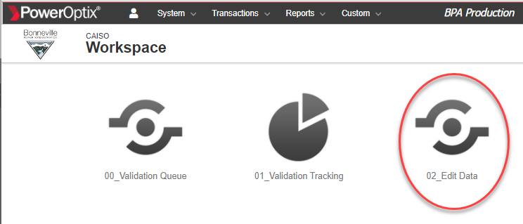

**Step 3** – the Edit Meter Interval Amounts screen will display. Select the meter point (location) you wish to edit.

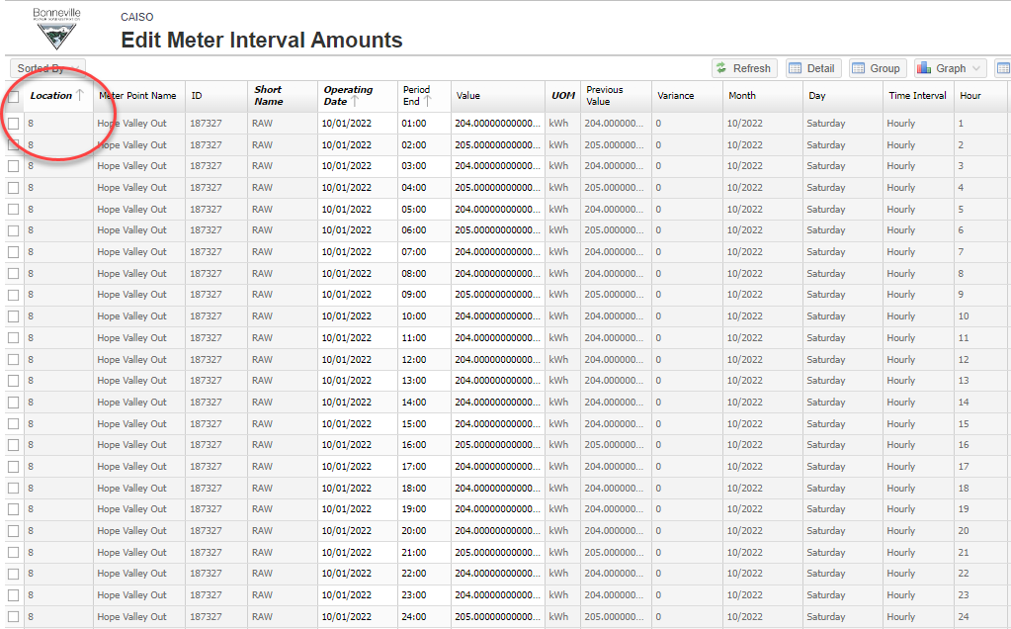

**Step 4** – Select the date/time you wish to edit by either choosing the specific Operating Date, or using the Manage Filter option in the lower right-hand corner of the screen.

* Initially the screen opens with the month of data that is related to the Billing month selected.
* To select the date you wish filter on Operating Date, then Filters, then ‘On’ for a specific day or filter on ‘From’ for a larger date range. Select the date you wish to display and the data for the selected date range will appear on your screen.

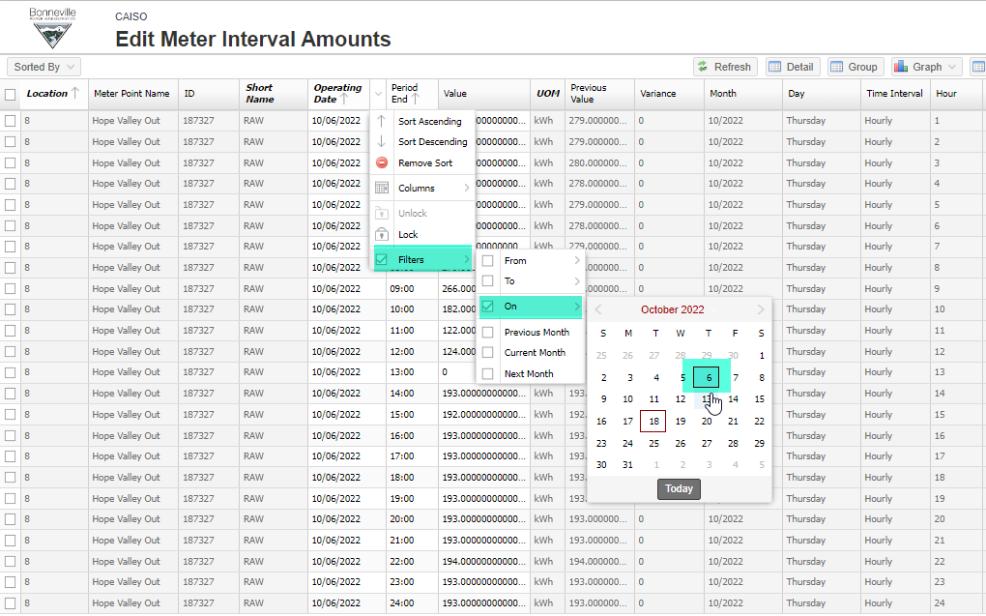

* Edit the data

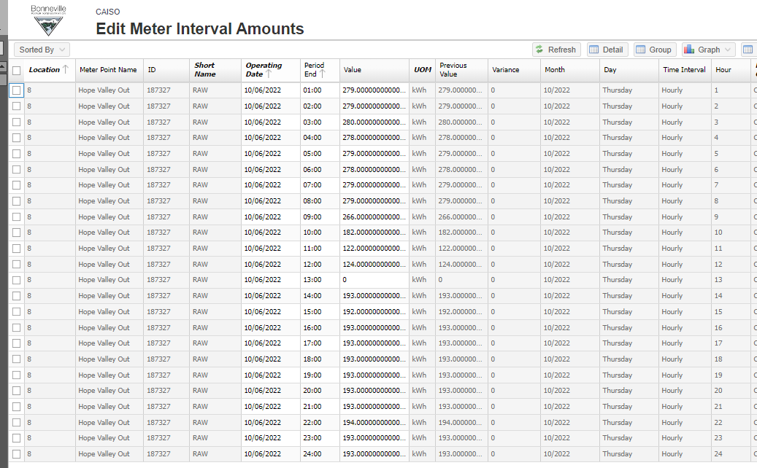

Manage Filter option:

* Select your dates
* Apply

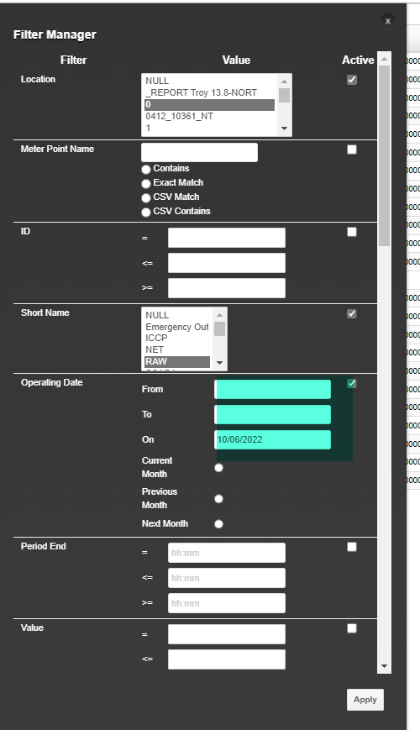

**Step 5** – There are several ways to edit data on Meter Data Detail:

1. Manual entry of the record you wish to update
2. The Adjustment button allows user to update selected records and adjustment by Fixed (Amount), Percentage, and Change Value To. This feature allows for both increases and decreases by using the negative sign
   1. Fixed – increases or decreases the Value by the same number entered
   2. Percentage – increases or decreases the Value by a percentage entered
   3. Change Value To – changes all values to the same number
3. Exporting to csv, modifying as desired for this date, and pasting back into PowerOptix.
4. Once you have edited the interval(s) you wish, click ‘Save’.

**Editing missing Volts in PowerOptix**

If a gap in data occurs from PrimeStone-MDC and that device is setup with volt channels, the missing data for the votls will need to also be edited/filled in for the VTP to continue to move ahead in time.

**Step 1 -** Determine which intervals are missing data. In the case below, 9/21 is missing a few volt intervals for A/B/C for that day.

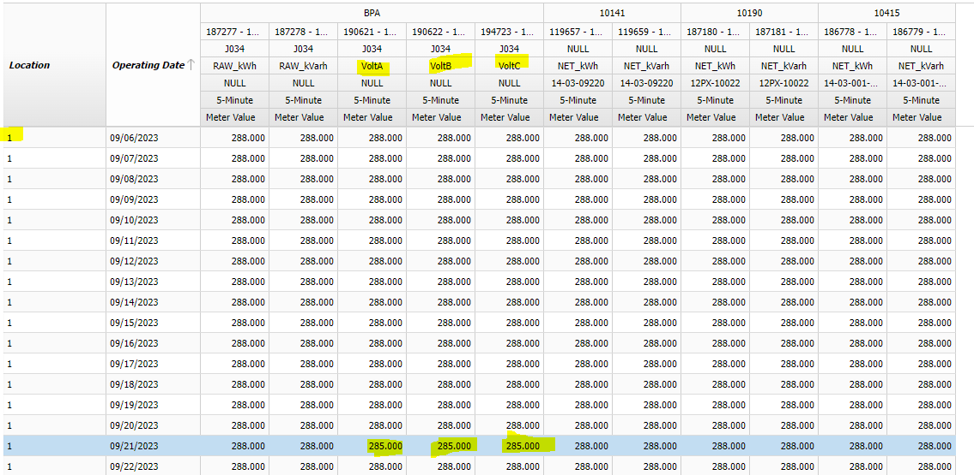

**Step 2 -** You can open 9/21 in the edit view to see which intervals are impacted (will be in the reports in a few months) OR you can filter to show just the day(s) impacted, in this case 9/21 only, then click Pivot Data, select ‘Interval’ in the left hand pane ‘Available Fields’ section (it will be auto-applied to the Group By area which is correct), then click ‘Apply’. This gives you a view much like the reports.

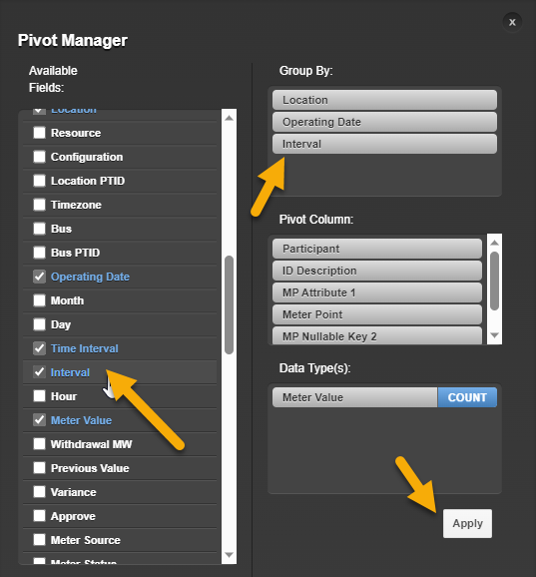

As long as you have other data in place for the other intervals this is missing for, the MDDV view will show a gap. If all were missing, all rows would be missing. In this case, volt data is missing for 1105/1110/1115 for 9/21.

**Step 3 -** Because volt data is repeatable and not used for billing or other revenue purposes, data for these intervals should just be ‘copied forward’ from either the day before or after the gap.

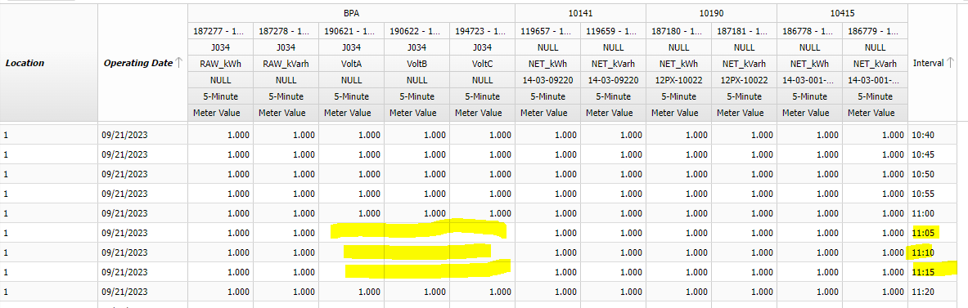

**Step 4 -** Open the Edit View favorite. Under ‘Manage Filters’ in the bottom left corner change the following.

* Location = hand key in the location needed
* Unclick the filter on ‘Short Name’ (check box to the right of it when the Manage Filters pane is up)
* Operating Date = enter the date you want to copy data to/from. In this case we’ll pick 9/20 only, no range needed.
* UOM = scroll down the list and click ‘VoltA’. Then, holding down the control key, click VoltB and VoltC so they’re all selected.
* Click Apply

Due to an existing bug, the screen may not bring anything back. If this happens, in the header under ‘Current’ make sure ‘Yes’ is selected and the checkbox to apply the filter is also checked. This will all work seamlessly after the 10/23/23 PROD release. Below is a quick screenshot showing the issue and how to fix it:

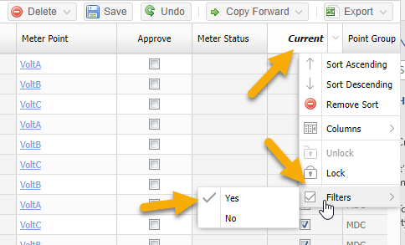

**Step 5 -** The UI should sort all data in groups of intervals by time so just find the ones you need and copy forward to the day needed.

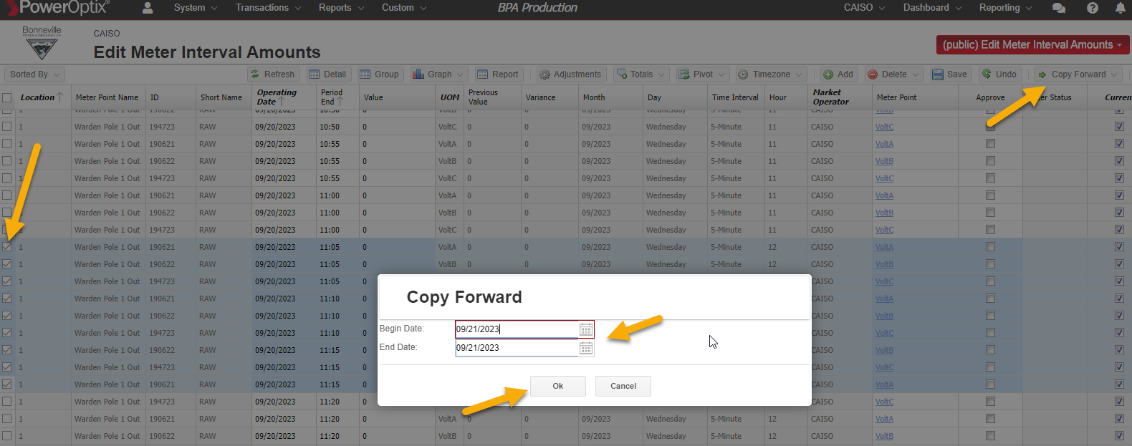

**Step 6 -** Double check on MDDV and confirm the missing volt reads have filled in. Depending on the time of day and how big the Change Queue is, this could be almost instant or could take a couple of hours.

# References

## Standards

* Estimations are required when some or all of the served load or generation has not been recorded by the meter which could cause inaccurate billing.
* Meter events are created/updated with all information pertaining to the specific event and all estimation documentation is attached for reference.

## Guidelines

There are a number of factors that may determine the appropriate estimation method

1. Number of intervals requiring estimation
   1. A greater number of intervals may require more complex methods
2. Type of correction required
   1. Estimation of total load tends to be more complex than an estimation to correct a loss of phase or an incorrect multiplier where partial load has been successfully metered
3. Load shape of meter point
4. Less predictable shapes usually require more complex methods
5. Where the estimation period “falls” on the load shape
   1. Whether the load/generation is increasing, decreasing, or relatively flat will determine whether a simple straight-line method can be used or a more complex method is required
6. Load shifts or outages that coincide with estimation period
   1. Incorporation of any coincidental power outages or load shifts will require complex methods
7. Availability of B Meter, customer supplied data, or a valid SCADA match
   1. Valid replacement data will be used for most all estimations when available
8. Estimated Totals
   1. If various methods seem reasonable for a time range, total amounts estimated may be compared from each option to determine best outcome for the customer. Select the estimation methodology that corresponds the closest with the surrounding reads. When done with precision, a person reviewing unmarked estimation reads should not be able to “pick them out” from the valid surrounding reads.
9. Several different methods can be used in determining the best outcome.
10. For more complex estimations, collaboration with the customer is recommended.
11. When using customer supplied data – double checking that the data supplied by the customer and the data input into the metering system matches. This can be done by verifying totals, as well as doing a side-by-side comparison of the data. A final check can also be done by comparing the data reported to MDMR2 with the data supplied by the customer.
12. Unlike the PrimeStone readings, the estimation values need not be limited to a multiple of the pulse multiplier.
13. If an MDA notices an anomalous reading on any meter, including IN-meters, they should investigate the cause. IF it is determined that meter should be a zero meter, the MDA should zero out that meter read before releasing the data to Billing.
14. When estimating generation values, a customer supplied file or available SCADA as the source is highly preferred. Only in very rare circumstances can generation values be estimated using historical values as a reference***.***
15. MSM has implemented secondary reviews of manual edits for intervals of two days or longer. This will be followed for T+3, T+5 and T+48-meter data used for EIM settlement purposes.  The actions taken will ensure secondary reviews and approvals are completed for high-risk (two days or longer) changes to EIM-S data submittals. These reviews will be completed by other analysts in MSM. Any needed secondary reviews for edited intervals of two days or longer will be documented in the PowerOptix events, which includes the edit documentation and any supporting emails supporting the decision to edit this interval. This information is available in MDMR2 to be viewed by customers as needed.

## Forms, Templates and Checklists

Several macros have been developed for use in estimating interval data. These macros are as follows, all of which can be found on the MSM Process and Workflow SharePoint site under ‘[Working Documents](https://portal.bud.bpa.gov/orgs/cust-sppt-svcs/KSM%20Metering%20Services/Process%20and%20Workflow%20FUTURE%20STATE/Shared%20Documents/Forms/AllItems.aspx?&&p_Category=Procedures&p_SortBehavior=0&p_FileLeafRef=Loss%20Factor%20to%20Loss%20Equation%20Conversions%2edocx&&PageFirstRow=1&&View=%7bCFEA32E0-0A0B-4C5B-BC90-FCE89FC48235%7d&InitialTabId=Ribbon%2EDocument&VisibilityContext=WSSTabPersistence)’.

* 5 min to Hourly macro
* 15 minute to Hourly macro
* 15 min to 5 minute macro
* Daily to 30 minute macro
* Hourly to 5 minute macro
* Hourly to 15 minute macro
* Hourly to 30 minute macro
* Rows to Columns Spreadsheet here

## Training

None

# Review

## Procedure Evaluation

TBD

## Review Timeline

MSM procedures are reviewed annually at a minimum if there are no changes to systems or organization discrepancies that affect this procedure.

|  |  |  |
| --- | --- | --- |
| Date | Change | User |
| 9/26/2024 | Added language re: secondary reviews for EIM meters | KSR |
| 6/20/2024 | Added clarification regarding complex edit approach and working with the customer for agreement on final complex edits. | ASC |
| 2/26/2024 | Updated references from KSM to MSM. Validated and updated hyperlinks. | ASC |
| 1/2/2024 | Added instructions for editing/filling in gaps in volt data. | MRR |
| 9/27/23 | Updated references from FY23 to FY24 on page 6 | BK |
| 4/10/2023 | Ran through grammer and spelling checks. Few other formatting and content changes beyond that. | MRR |
| 10/20/22 | Merged VEE Logic with this procedure and renamed. Updated screenshots for Editing Data | KSR |
| 10/12/21 | Added screenshots for Editing Data | KSR |
| 10/07/21 | Updated procedure prior to 11/1 go-live with new systems | KSR/JSR |